Name-Ujjawal Mandhani
Batch-F6
Enroll no.-9918103237
OSSP Lab Test 2

Question 1:

(a)

#include <stdio.h>
int main()
{
int n, m, i, j, k;
n = 4;
m = 1;
int alloc[4][1] = {{1},
{1},
{4},
{2}};
char name[4][10] = {"A", "B", "C", "D"};
int max[4][1] = {{6},
{5},
{7},
{4}};

int avail[1] = {2};

int f[n], ans[n], ind = 0;
for (k = 0; k < n; k++)
{
f[k] = 0;
}
int need[n][m];
printf("Need matrix :\n");
for (i = 0; i < n; i++)
{
for (j = 0; j < m; j++)
{
need[i][j] = max[i][j] - alloc[i][j];
printf("%d\t", need[i][j]);
}
}

printf("\n");
return (0);
}

need matrix is
Need matrix :
5 4 3 2
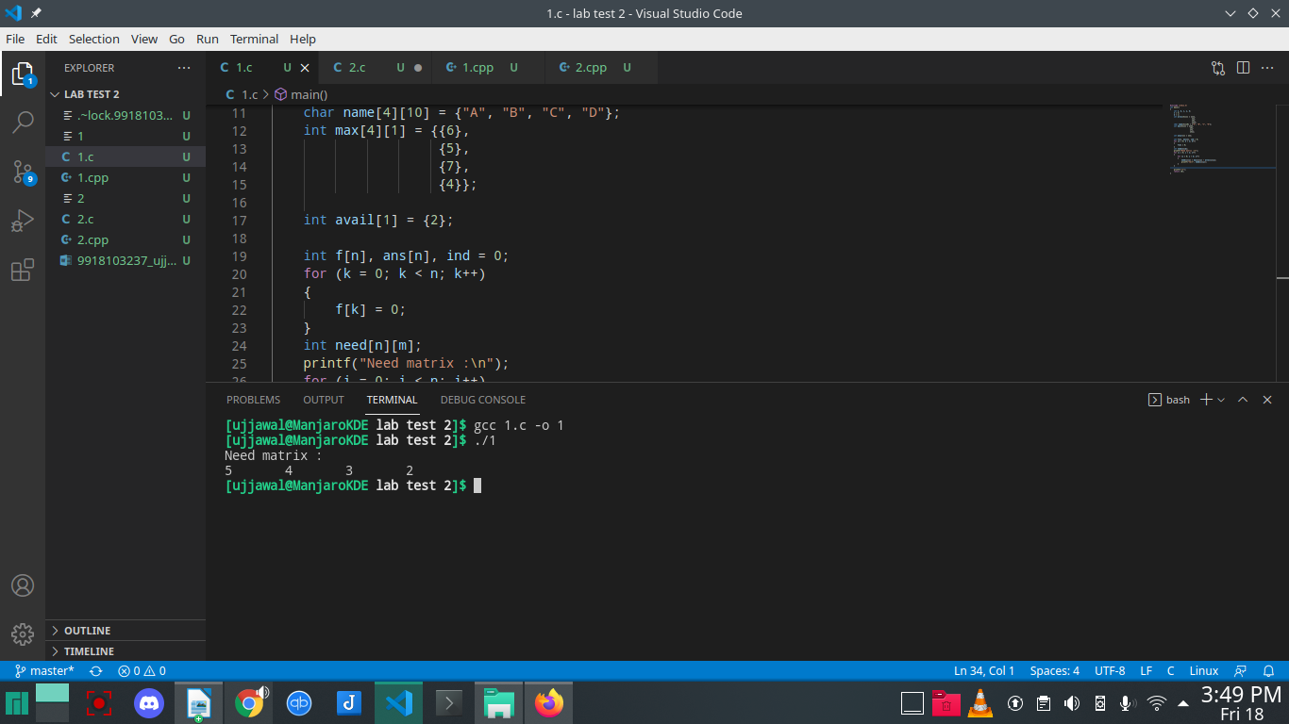
(b)

#include <stdio.h>
int main()
{
int n, m, i, j, k;
n = 4;
m = 1;
int alloc[4][1] = {{1},
{1},
{4},
{2}};
char name[4][10] = {"A", "B", "C", "D"};
int max[4][1] = {{6},
{5},
{7},
{4}};

int avail[1] = {2};

int f[n], ans[n], ind = 0;
for (k = 0; k < n; k++)
{
f[k] = 0;
}
int need[n][m];
printf("Need matrix :\n");
for (i = 0; i < n; i++)
{
for (j = 0; j < m; j++)
{
need[i][j] = max[i][j] - alloc[i][j];
printf("%d\t", need[i][j]);
}
}

int y = 0;
for (k = 0; k < 5; k++)
{
for (i = 0; i < n; i++)
{
if (f[i] == 0)
{

int flag = 0;
for (j = 0; j < m; j++)
{
if (need[i][j] > avail[j])
{
flag = 1;
break;
}
}

if (flag == 0)
{
ans[ind++] = i;
for (y = 0; y < m; y++)
avail[y] += alloc[i][y];
f[i] = 1;
}
}
}
}

printf("\nFollowing is the SAFE Sequence\n");
for (i = 0; i < n - 1; i++)
printf(" P%d ->", ans[i]);
printf(" P%d\n", ans[n - 1]);
for (i = 0; i < n - 1; i++)
{
int j = ans[i];
printf(" %s -> ", *(name + j));
}
j = ans[n - 1];
printf("%s", *(name + j));
printf("\n");
return (0);
}

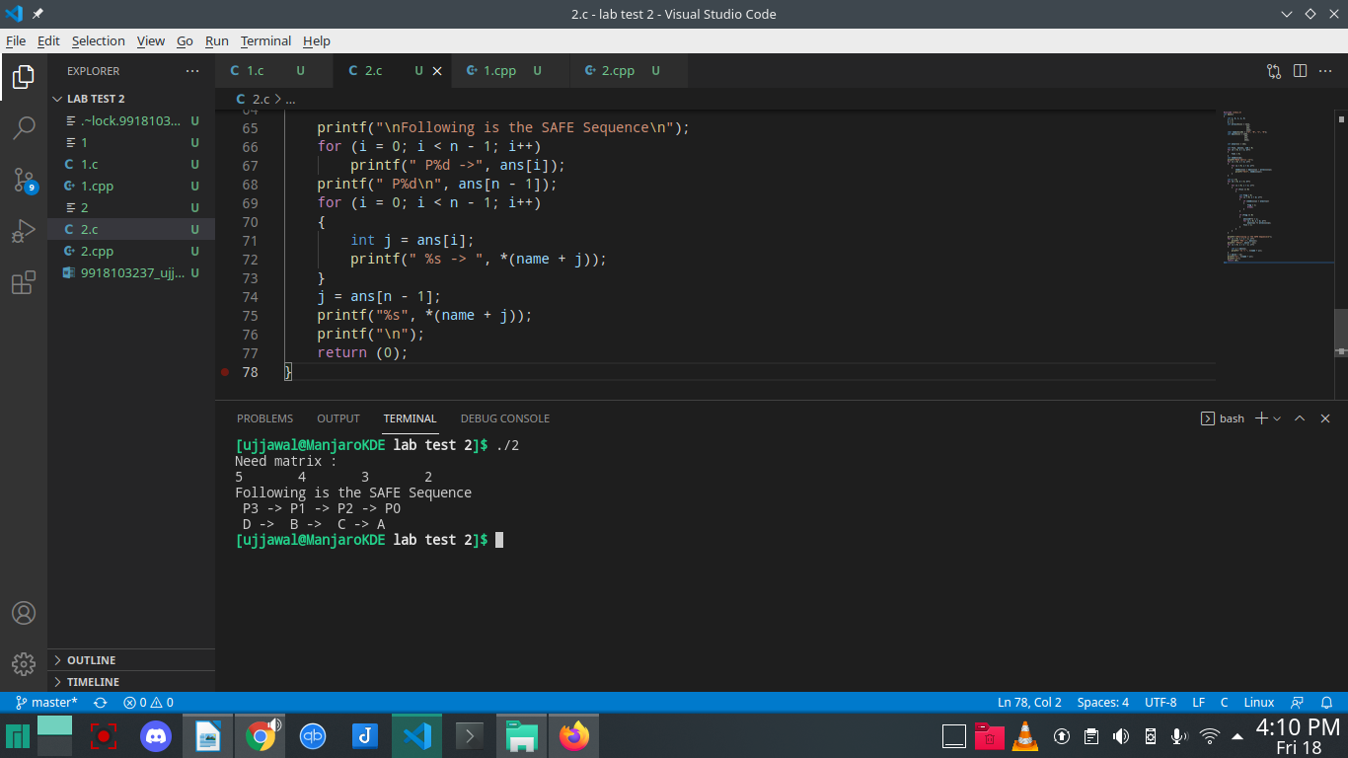

Question 2:

#include <stdio.h>
#include <stdlib.h>
#include <unistd.h>
#include <pthread.h>
#include <malloc.h>
int **arr;
double *gd;

void *gettingMarks(int n)
{
int i;
printf("Enter the marks in 5 subjs of %d students\n", n);
for (i = 0; i < 5; i++)
{
scanf("%d \n", &arr[n][i]);
}
return NULL;
}

void *calcGrade(int n)
{
double grade = 0.0;
int i;
for (i = 0; i < 5; i++)
{
grade = grade + arr[n][i];
}

gd[n] = grade / 5 * 100;
return NULL;
}

int main()
{
pthread_t t1;
pthread_t t2;
int n = 0, i;
printf("Enter the number\n");
scanf("%d \n", &n);
*arr = (int *)malloc(n * sizeof(int));
for (int i = 1; i < 5; i++)
{
arr[i] = (int *)malloc(5 * sizeof(int));
}
gd = (double *)malloc(n * sizeof(double));
for (i = 0; i < n; i++)
{
pthread_create(&t1, NULL, gettingMarks(i), NULL);
pthread_create(&t2, NULL, calcGrade(i), NULL);
pthread_join(t1, NULL);
pthread_join(t2, NULL);
}
printf("After Thread\n");
exit(0);
}

